MAULANA FIGO AL MAHDI

09.2020.1.00674

QUIS DESAIN IPAL

1A. Gambar 1

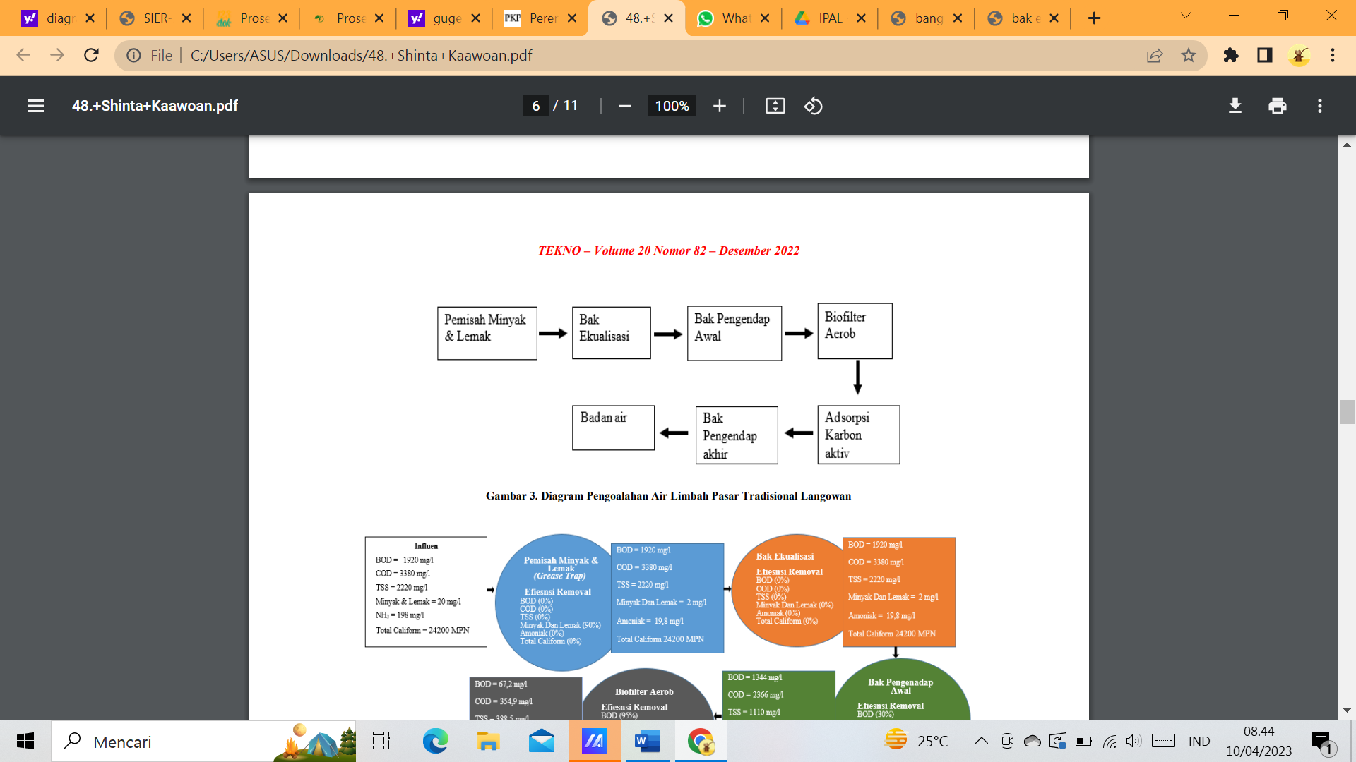

Kaawoan, S. P., Mangangka, I. R., & Legrans, R. R. (2022). Perencanaan Instalasi Pengolahan Air Limbah (IPAL) Pasar Tradisional Langowan Di Kecamatan Langowan Timur Kabupaten Minahasa. *TEKNO*, *20*(82), 905-915. <https://scholar.google.com/scholar?hl=id&as_sdt=0%2C5&q=diagram+alir+ipal&btnG=>

Gambar 2

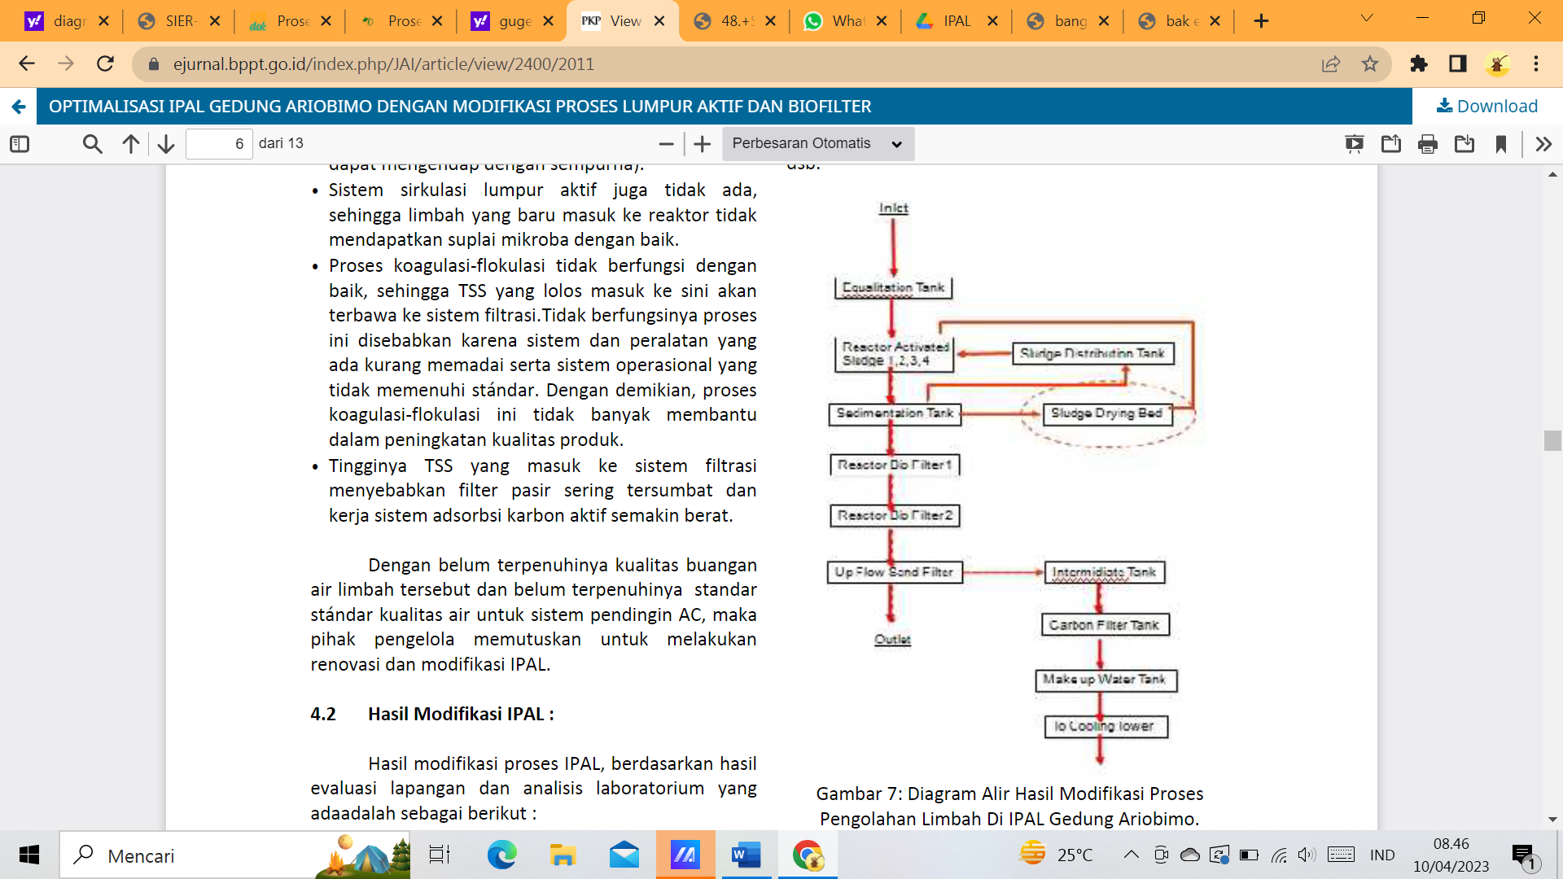

<https://ejurnal.bppt.go.id/index.php/JAI/article/view/2400/2011>

1B. Gambar 1

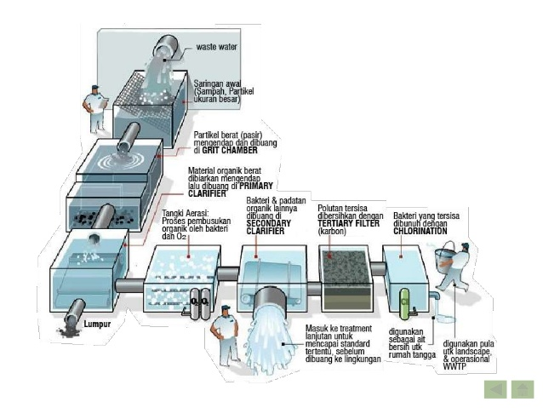

<https://materikimia.com/wp-content/uploads/2019/02/Skema-IPAL-Instalasi-Pengolahan-air-limbah.jpg>

gambar 2

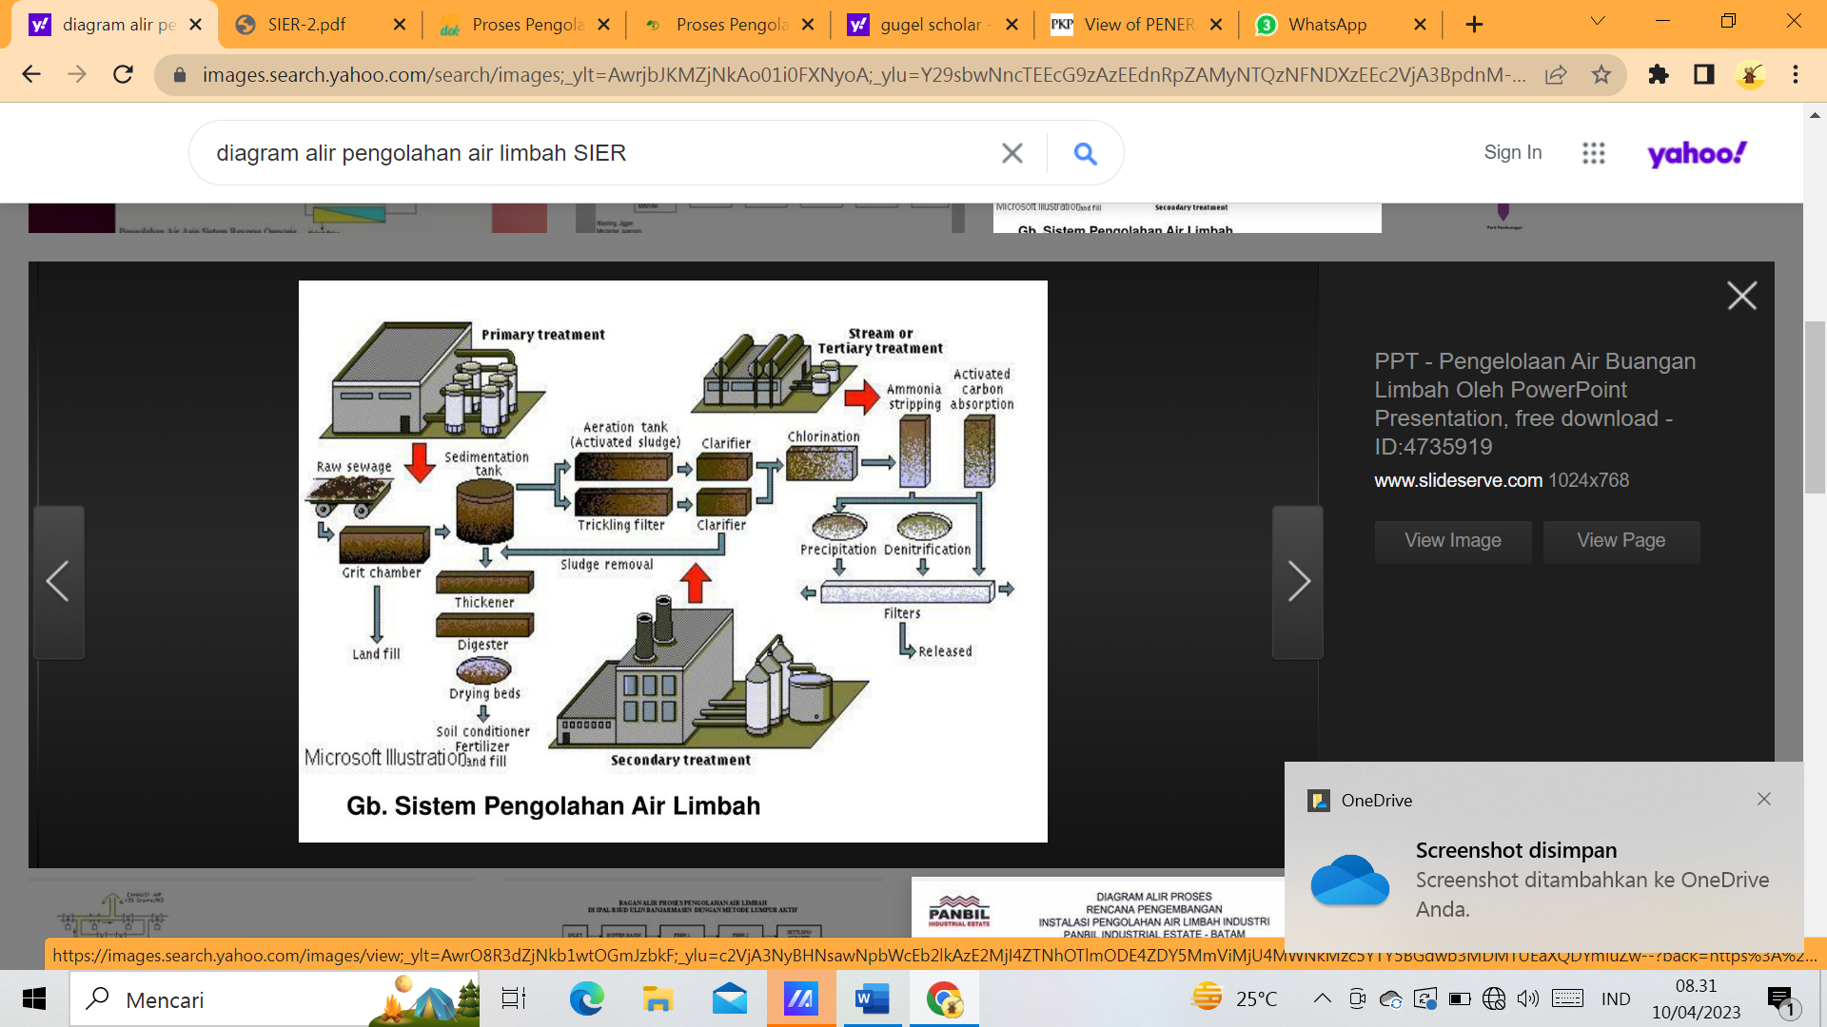

<https://image2.slideserve.com/4735919/slide2-l.jpg>

1C. Gambar 1

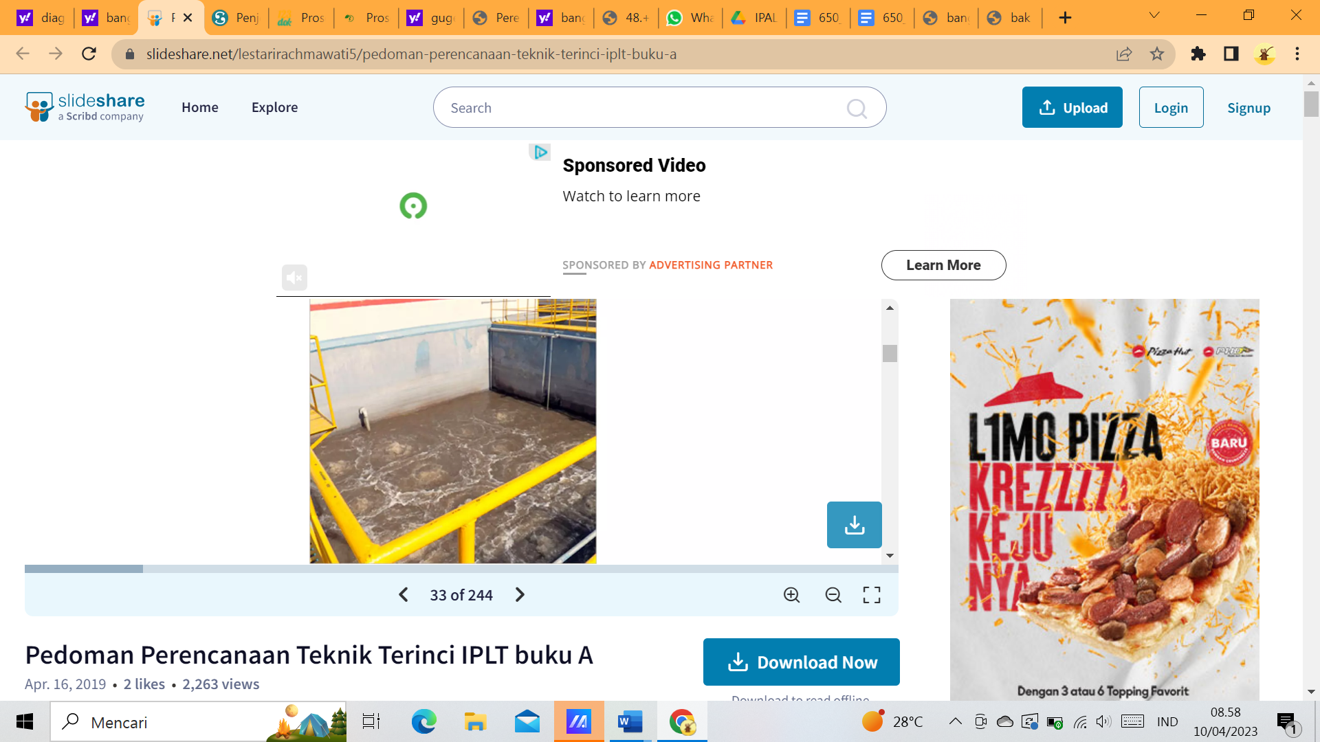

<https://www.slideshare.net/lestarirachmawati5/pedoman-perencanaan-teknik-terinci-iplt-buku-a>

Gambar 2

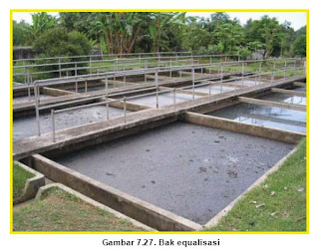

<http://4.bp.blogspot.com/_JL-HawAeuYM/SzoJQ2ZUy6I/AAAAAAAAAIE/pA4JL-8UHGI/s320/a.jpg>

1D. Gambar 1

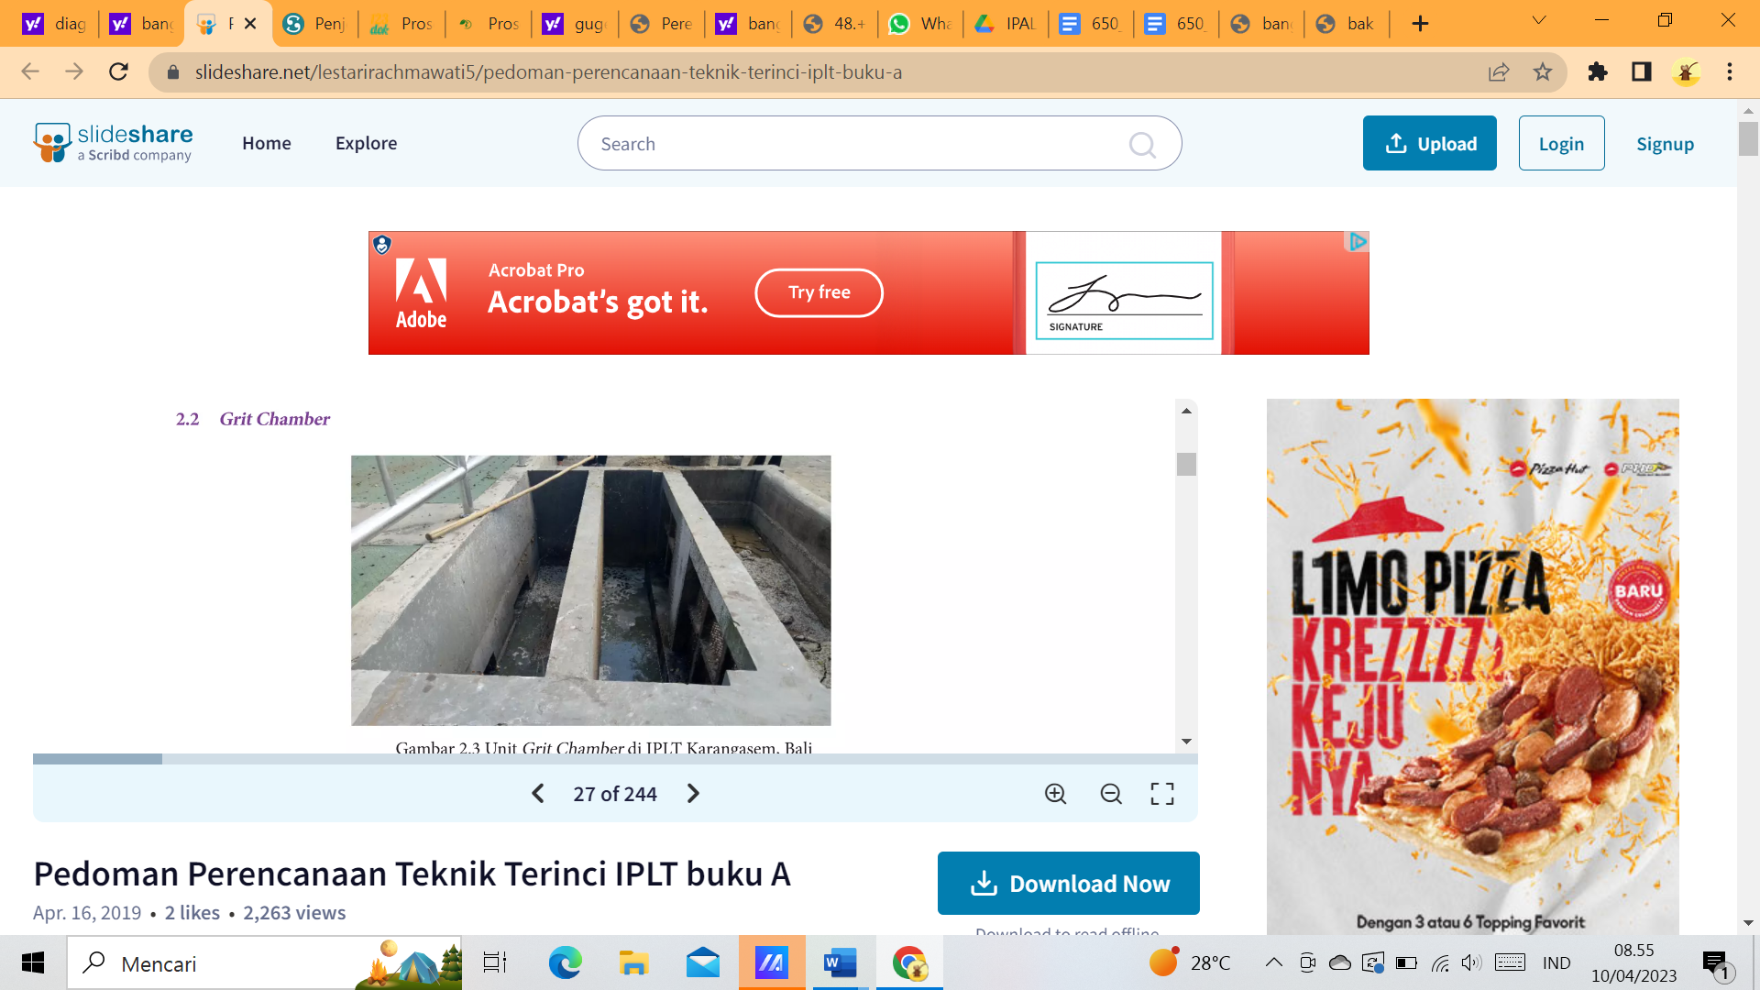

<https://www.slideshare.net/lestarirachmawati5/pedoman-perencanaan-teknik-terinci-iplt-buku-a>

Gambar 2

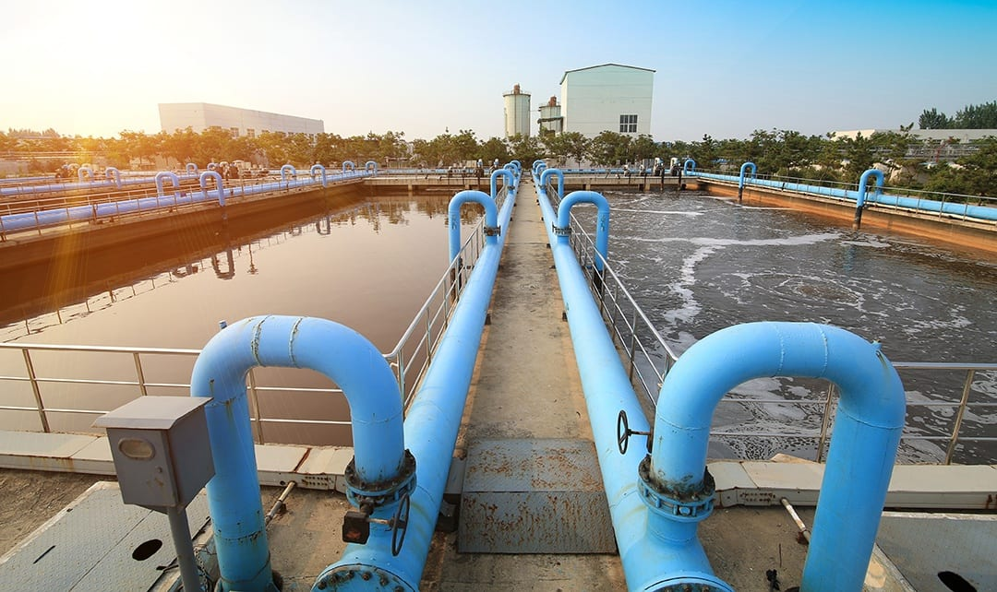

<https://mk0whitacreengibnc2a.kinstacdn.com/wp-content/uploads/2018/05/GritChamber.jpg>

2. **Perhitungan Bangunan Grit Chamber**

Diketahui :

Q = 0,6 m3/s

Direncanakan :

* 2 unit grit chamber (beroperasi bergantian)
* Lebar = W = 0,75 m
* Vh = kecepatan horisontal = 0,3 m/det
* Partikel grit berukuran 100 mesh
* Vs = kecepatan settling = 0,8 m/menit = 0,013 m/det
* Spesifik gravity = Sg = 2,65
* Koefisien k = 0,05
* Koefisien f = 0,02
* Viskositas = 0,8975 × 10-6 m2/detik pada suhu 25oC
* Berat jenis air = ρ = 1.000 kg/m3

1. Dimensi Bak

Cross Area :

Ac =

=

= 0,2 m2

Kedalaman :

Ac = w × h

H = $\frac{Ac}{w}$

= $\frac{0,2 m^{2}}{0,75 m}$

= 0,26 m

Panjang Grit Chamber :

$\frac{L}{Vh}$ = $\frac{H}{Vs}$

L = $\frac{Vh × h}{Vs}$

= $\frac{0,3 m/s × 0,26 m }{0,013 m/s}$

= 6 m

Surface Area (As) :

As = L × w

= 6 m × 0,75 m

= 4,5 m2

td =

=

= 1,46 detik

Karena td < 60, maka dimensi diubah menjadi :

L = 16 m

W = 2 m

h = 2 m

td = $\frac{16 m × 2 m × 2 m}{0,6 m^{3}/s}$

= 64 detik .... > 60 detik, OK!

1. Kecepatan Scouring (Vsc)

Vsc = 1/2

= 1/2

= 2,54 m/s

Vsc > Vh........OK!

1. Grit Storage

Q = 0,6 m3/s × 86400 s/hari

= 51.840 m3/hari

Q grit = × ×

= 0,51 m3/hari

Perencanaan volume dan dimensi ruang pengumpul grit, di bagian bawah

grit chamber :

A1 → L = 15 m

W = 2 m

A1 = 15 m × 2 m

= 30 m2

A2 → L = 10 m

W = 1 m

A2 = 10 m × 1 m

= 10 m2

V = (A1 + A2 + √A1 × A2)

0,51 = (30 + 4+ √30× 4)

0,51 = $\frac{t}{3}$ (30 + 4+22)

0,51 = $\frac{t}{3}$ (56)

t = 0,077 m = 2,7 cm

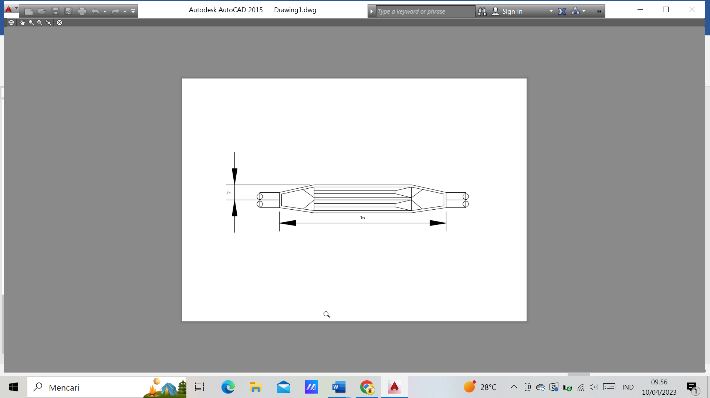

DENAH BANGUNAN GRIT CHAMBER

SKALA 1 : 100